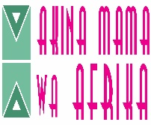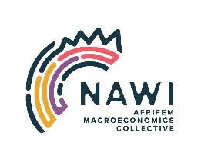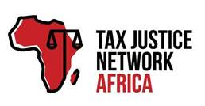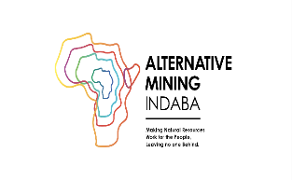

Alternative Mining Indaba Virtual Panel Session

"Just transitions for who?" A feminist perspective

Convenors: The Nawi Collective, Akina Mama Wa Afrika, For Equality Africa, Tax Justice Network Africa

4th May 2022
2:00 - 3:30 PM CAT

Panellists: Salimah Valiani, Researcher, Activist & Poet
Faith Lumonya, Economic Justice, and Climate Officer

Moderator: Ikal Angelei

Duration: 1 hr 30 mins

The Problem

Urgent action is needed to address the climate crisis. The problem is universal, yet the impacts, responsibilities, and capacities to respond are differentiated and unequal across regions, countries, and communities world-wide. The oil, gas and mining sector have been a major contributor to the climate crisis Domestic and continental action is imperative. Yet African countries historically and currently are among the lowest emitters of the greenhouse gases that drive global warming. Ambitious action on climate change requires a transformative feminist agenda that centres women’s rights and leadership on the experiences of mining communities who are at the frontline and in negatively impacted communities.

The session will adopt a feminist perspective to collectively analyse the climate crisis and peoples' energy transition by exposing the capitalist system and its role in undermining women, and their power in driving transformation. Extractive’s oligopolies and corporatized politics have imposed humiliating austerity measures, privatisations of public services, and excessive and growing socio-economic inequality, displacement and dispossession, and environmental destruction. These processes have driven skyrocketing levels of energy poverty and a worsening ecological crisis. The most exploited and discriminated people are hit the hardest: from women in low-income households, women of colour and women with disabilities, to transwomen, single mothers, and undocumented women.

Objectives of the Webinar

Overall objective
To centre the intersectional feminist narrative in the current climate justice and energy transition conversation at the Africa Mining Indaba

Objectives
- To deepen reflections on the current state of mining communities, climate change and energy transition to generate fresh and bold ideas for transformative change.
- To build solidarity with mining communities, women and indigenous peoples campaigning for a just and inclusive climate transition.
- To strengthen and amplify the voices of feminists, women and communities' agency and voice for the integration of intersectional feminist approaches to sustainable mining and energy transition efforts.

The Alternative Mining Indaba Virtual Side Event
Akina Mama Wa Afrika, The Nawi Collective, For Equality and TJNA are inviting CSOs, policy makers, Women’s Rights Organizations, feminist groups/activists, researchers, and the general citizenry to discuss mining, climate change and the energy transition from a feminist perspective.

DRAFT AGENDA

14h00 – 14h05 Welcome Remarks/Webinar Overview
Moderator: Ikal Angelei, Friends of Lake Turkana (FOLT)

14h05 – 14h15 Watch Video on Energy Transition in Africa to set scene
The energy Africa needs to develop -- and fight climate change | Rose M. Mutiso


14h15 – 14h45 Salimah Valiani, Researcher, Activist & Poet (Main Presenter)

14h45 – 14h55 Faith Lumonya, Economic Justice, and Climate Officer, Akina Mama Wa Afrika

14h55 - 15h20 Q&A/Open discussion

15h20 – 15h25 Closing Remarks
Ikal Angelei, FOLT

15h25 – 15h30 Announcements on Alternative Mining Indaba
Mukupa Nsenduluka

Social Media Poster: Twitter, Facebook & LinkedIn

